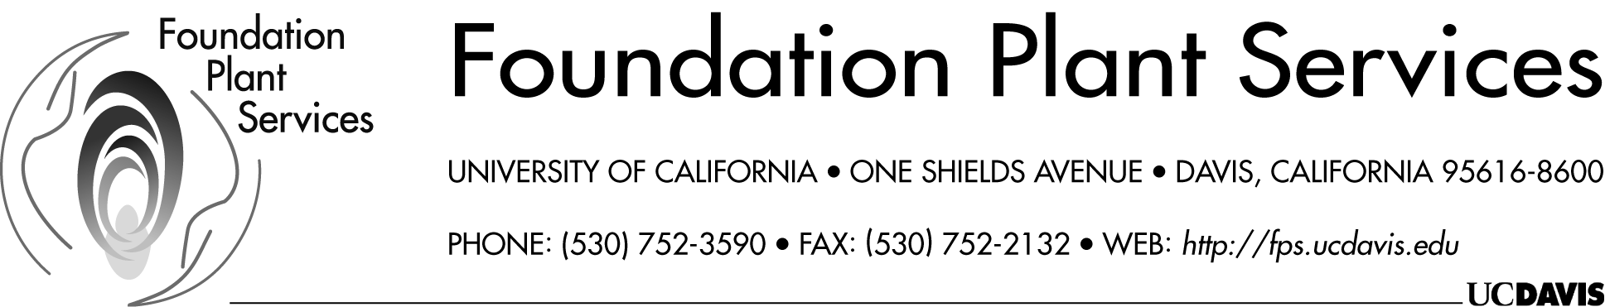
FPS Fruit & Nut Tree Advisory Committee Meeting
Wednesday, December 12, 2018 10:00am-12:00pm
Luncheon following Meeting
Peter Christensen Conference Room,
Trinchero Family Estates Building, UC Davis
http://fps.ucdavis.edu/tfeb.cfm

F R U I T & N U T T R E E C O M M I T T E E A G E N D A

- Welcome and introductions – Jack Poukish, Committee Chair

- Approve minutes from January 9, 2018, Committee meeting

- FPS Tree Collection and Virus Therapy Program Updates – Joshua Puckett, Production Manager, Foundation Plant Service

- Goals for improving Tree Virus Detection at FPS – Maher Al Rwahnih, Foundation Plant Services

- Updates from the Peach/Almond breeding program – Dr. Tom Gradziel, UCD Department of Plant Sciences

- News from the USDA Clonal Repository – John Preece, Research Leader, USDA-ARS Clonal Repository

- Progress Report on the Activities of the National Clean Plant Network – Deborah Golino, Director, Foundation Plant Services

- Other Business

